THE PRESIDENT’S OFFICE
REGIONAL ADMINISTRATION AND LOCAL GOVERNMENT
NAMANGA SECONDARY SCHOOL
FORM FOUR PRE-MOCK EXAMINATION
031 PHYSICS
MARKING SCHEME 2025
SECTION A (16 MARKS)
- Answer…………………………………10 marks@1
i | ii | iii | iv | v | vi | vii | viii | ix | x
B | D | B | C | A | A | D | C | D | D

- ……………6 marks @1
List A | i | ii | iii | iv | v | vi
List B | F | H | G | E | B | C

SECTION A (54 MARKS)

- Recombination of dispersed white light ………………………4 marks
- Occurs when the second prism is reversed with respect to first prism
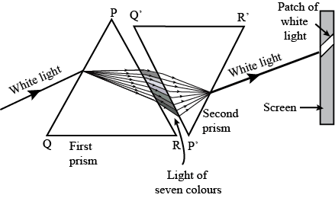

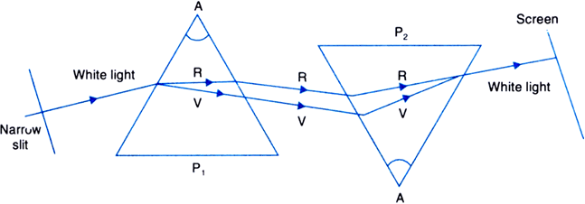
OR

- Using mirror formula
$\frac{1}{f}= \frac{1}{u}$ + $\frac{1}{v}$
$\frac{1}{v}= \frac{1}{f}$ - $\frac{1}{u}$
$$Sketch$$
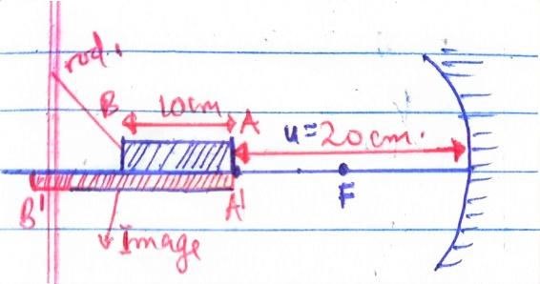
For the first end of the rod (end A)
$\frac{1}{V_{1}}= \frac{1}{f}$ - $\frac{1}{u}$
$V_{1}$ = $\frac{fu}{u-f}$
$v_{1}$= $\frac{10 ×20}{20-10 }$
$$v_{1=20cm }$$

For the second end u become 20cm +10cm
U = 30cm
Then $v_{2}$ = $\frac{fu }{u-f}$
$$v_{2}= \frac{10 ×30}{30-10 }$$
$$v_{2}=15cm$$
Then the length of the image = 20 cm -15 cm
= 5 cm. …………………………………..5 marks

- (a)(i)
  - Because pressure is greater at the bottom than at the surface……………..02 marks
(ii)
Many tyres increases surface in contact with the ground which reduce average pressure of truck. Hence the truck does not tear the road or stuck in the ground ………………02 marks
- Solution
        - Rods weight $w_{1}$=mg = 0.12 x 10 = 1.2N (at the centre of the rod)
Let $w_{2}$ hang from the right end
Wire
/////////////////
Uniform rod
80cm
$$w_{1}=1.2N$$
$w_{2}$ = ?
15cm
50cm
65cm
T

Weigh of the rod ($w_{2})$cause anticlockwise moment while unknown weight ($w_{2}$) cause clockwise moment
From principle of moments
$$\sum{c.m}=\sum{a.c.m}$$
$$w_{1}d_{1}=w_{2}d_{2}$$
$$w_{2}= \frac{w_{1}d_{1}}{d_{2}}$$
$w_{2}=\frac{1.2N ×0.15m}{0.5m}$ = 0.36N = 36g……………….3marks
Therefore mass of 36g is required to be hang to the right end.
        - For rod to be in equilibrium , tension must be equal to the total weight
T = 1.2N + 0.36N
T = 1.56N……………………….2 marks
- (a) (i)
- If a body is moving with a constant velocity, there is no external force acting on it, therefore its acceleration is zero.
F = ma
But a = 0m/s².
Then F = m x 0
F = 0N……………………………..02marks
(ii)
- No , because there may be some balanced forces acting on object ,hence object not move ……………………………..2marks

- VR = $\frac{number of teeth on drivven gear}{number of teeth in driving gear }$ = $\frac{80}{20}$

V.R = 4…………………02marks
- Let
R_{A} = Rotation in A
T_{A} = Number of teeth in A
R_{B} = Number of rotation in B
T_{B} = Number of teeth in B
R_{A}$×$T_{A} = R_{B} $×$ T_{B}
3 $×$20 = R_{B}$×$ 80
R_{B} = $\frac{60}{80}$ = $\frac{3}{4}$…………………..03marks

- (a) A beaker containing water ice is heated from -5⁰C to 0⁰C and then from 0⁰C to 15⁰C.
With the aid of a diagram, explain the variation of density with temperature. (4 marks)
Answer
When the ice is heated at -5⁰C 0⁰C then heated to 15⁰C, its density will increase from the temperature of -5⁰C to 4⁰C where it is maximum with value of 1g/cm³.Heating above 4⁰C the density of the liquid decreases
Graph of density against temperature.
Temperature (⁰C)

0
-5
4
15
Density (g/cm³)
Max density. 1 (g/cm³)

- A heater of 500w is used to raise the temperature of 50kg of material of specific heat capacity of 960J/kgK, from 18⁰C to 38⁰C. Assume that all the heat from the heater is given to the material. Calculate:
- Heat capacity of the material (2 marks)
- The time taken in seconds (3 marks)
Solution
- Heat capacity = mass x specific heat capacity
= 960 x 50
= 48000J/K……………………..02 marks
- Heat supplied = mc$∆T$
= 960 X 50 (38-18)
= 960,000J…………………….03 marks
But
Heat = Power x time
Time, t = $\frac{heat supplied }{power }=\frac{960,000}{500}$ = 1920seconds.

- (a) (i) The half-life of a certain radioactive substance is 64 days. Explain the meaning of this statement.(2 marks)
Answer
It means it takes 64 days for radioactive substance to decay to decay to its half
- The half-life of ${60}_{C_{o}}$ is 5 years .How much time does it take for $({\frac{3}{4}) }^{th }$of its initial mass to disintegrate?(4 marks)
Solution
Initial atomic mass No = 60
$t_{\frac{1}{2}}$ = 5years
$time$t =? Final amount N = ¾ X 60 = 15
From $\frac{N}{N_{o}}$ = ${\left(\frac{1}{2}\right)}^{\frac{t}{5}}$

$\frac{15}{60}$ = ${\left(\frac{1}{2}\right)}^{\frac{t}{5}}$

$\frac{1}{4}$ = ${\left(\frac{1}{2}\right)}^{\frac{t}{5}}$

${\left(\frac{1}{2}\right)}^{2}$= ${\left(\frac{1}{2}\right)}^{\frac{t}{5}}$

2 = $\frac{t}{5}$

t = 10 years …………………………………...04 marks
- Thorium disintegrates in the following manners
${ 90}^{{Th}^{232}}$.$→{ 88}^{{Ra}^{228}}{→ 89}^{{Ac}^{228}}$.$→{ 90}^{{Th}^{228}}{→ 88}^{{Ra}^{224}}$.State the particle emitted at each part of the disintegration. (4 marks)

Answer
${ 90}^{{Th}^{232}}$.$→{ 88}^{{Ra}^{228}}$ + ${}_{2}^{4}{}α$ ($α-particle )$………………………………..01mark

${ 88}^{{Ra}^{228}}{→ 89}^{{Ac}^{228}}$ + ${}_{-1}^{0}{}β$ ($β$- particle) …………………………………...01mark

${ 89}^{{Ac}^{228}}$.$→{ 90}^{{Th}^{228}}$ + ${}_{-1}^{0}{}β$($β$- particle)…………………………………...01mark

${ 90}^{{Th}^{228}}{→ 88}^{{Ra}^{224}}$.+ ${}_{2}^{4}{}α$ ($α-particle )$…………………………………...01mark

$∴{ 90}^{{Th}^{232}}$.$\underset{→}{α}{ 88}^{{Ra}^{228}.\underset{→}{β}}{ 89}^{{Ac}^{228}}$.$.\underset{→}{β}{ 90}^{{Th}^{228}}{.\underset{→}{α} 88}^{{Ra}^{224}}$

- (a) Heliocentric theory is a theory which puts forward that the sun is at the centre of the solar system and all other bodies including the earth revolve around it…………….2 marks

Shortfall of heliocentric theory …………………………..3 marks @ 01mark
- The sun was thought to be at the Centre of the universe but it is only the Centre of the solar system.
- Orbits of the planets were thought to have circular shapes , but now days they are known to have elliptical shapes
- The relative positions of the stars seemed to remain the same despite the earths changing view points as it moved around the sun.

- A – Troposphere
Temperature in troposphere decrease because gases in this layer do not absorb radiation that enters the atmosphere…………………..1 mark
- Temperature in layer B increase due to presence of ozone layer that absorbs ultraviolet radiation.
The layer B is stratosphere …………………..1 mark
- Because it consist of charged particle called ions and free electrons responsible for propagation of electromagnetic wave. Radio waves can be reflected off the ionosphere allowing radio communication over long distance ……………………………..2 mark

SECTION B (30 MARKS)
Answer only two (2) questions from this section
- (a) (i) The electron will be deflected towards the positive plate as seen in figure below.

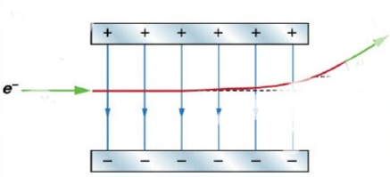
e -
e -
Initial direction
Deflection

- Walking barefooted during lightning storm will facilitate large amount of current from lighting strike to pass through your to the ground causing severe damage on you or some time cause death.

Solution
Hints R = 2$R_{0}$ V = $\frac{1}{3}V_{0}$
I = $\frac{V}{R}= \frac{\frac{1}{3}V_{0}}{2R_{0}}$ = $\frac{V_{0}}{6R_{0}}$ but $V_{0}= I_{0}R_{0}$
I = $\frac{I_{0R_{0}}}{6R_{0}}$
$$\frac{I}{I_{0}}= \frac{1}{6}$$

Solution
Given two dry cells each with emf,E = 1.5V
Internal resistance, r = 1.0Ω
I
E
I
r
r
E
10Ω
External resistance, R = 10Ω
Since the cells are in parallel;
Total emf = 1.5V
Equivalent resistance = R + $\frac{r × r}{r + r}$
= R + $\frac{r}{2}$
= 10 + $\frac{1}{2}$
= 10.5Ω
Current, I = $\frac{V}{R}$ = $\frac{1.5V}{10.5Ω}$ = 0.143A
Power = $I^{2}R$
= ${0.143}^{2}×10$
= 0.20W,……………………………………………5 marks
- (a) A strong current when passes through a semiconductor heats up the semiconductor and the covalent bonds break up. It results in a large number of free electrons. The material then behaves just as a conductor. As now the semiconductor no longer possesses the property of low conduction, it is said to be damaged…………………………….4 marks

- The statement means the small change in collector current cause greater change in base current………………………………..2 marks
- I_{C}$∝$ I_{B}
I_{C}$=β$I_{B}
Where $β$ = current gain
So
I_{C}$=β$I_{B}…………………………………………3 marks
- I_{B} = 2$μ$A
I_{C} =?
$β$ = 200
Then
I_{C}$=β$I_{B}
I_{C}$=200 × {2×10 }^{-6}$
I_{C} = 4 x ${10}^{-4}$A
I_{C} = 400$μ$A. ……………………………………3 marks
- When electrons are ejected from the negatively-charged electroscope, they escape, but in a positively-charged electroscope they are attracted back by the positive charge on the plate………………………….3 marks

- (a) Nature of the problem …………..01 mark
Helicopter
Bottom of lake
Water surface
x m
h=200m
- - - - - - - - - - - - - - - - - - - - -- - - - - - - - -- - - -- - - - - - - - - - - - - - - -

From v = $\frac{2d}{t}→t=\frac{2d}{v}$ = $\frac{2d}{331.4+0.6θ}$…………………0.5mark
Let $t_{1}=$ time taken by sound to reflect back from water surface,
$t_{1}=\frac{400m}{331.4+0.6θ}$………………………..0.5mark
Let $t_{2}=$ time taken by sound to reflect back from bottom of lake,
$t_{2}= \frac{2(200m+xm)}{331.4+0.6θ}$……………………….0.5mark
Difference in arrival time = 0.24s
$t_{2}-t_{1}$ = 0.24s
$\frac{400+2x}{331.4+0.6×20}-\frac{200}{331.4+0.6×20}$ = 0.24sec………………..0.5marks
400 + 2x
400 +2x = 480.76
2x = 80.76
x = 40.38
The depth of the lake = 40.38m……………………….03marks
- (i) diagram …………………………….4marks

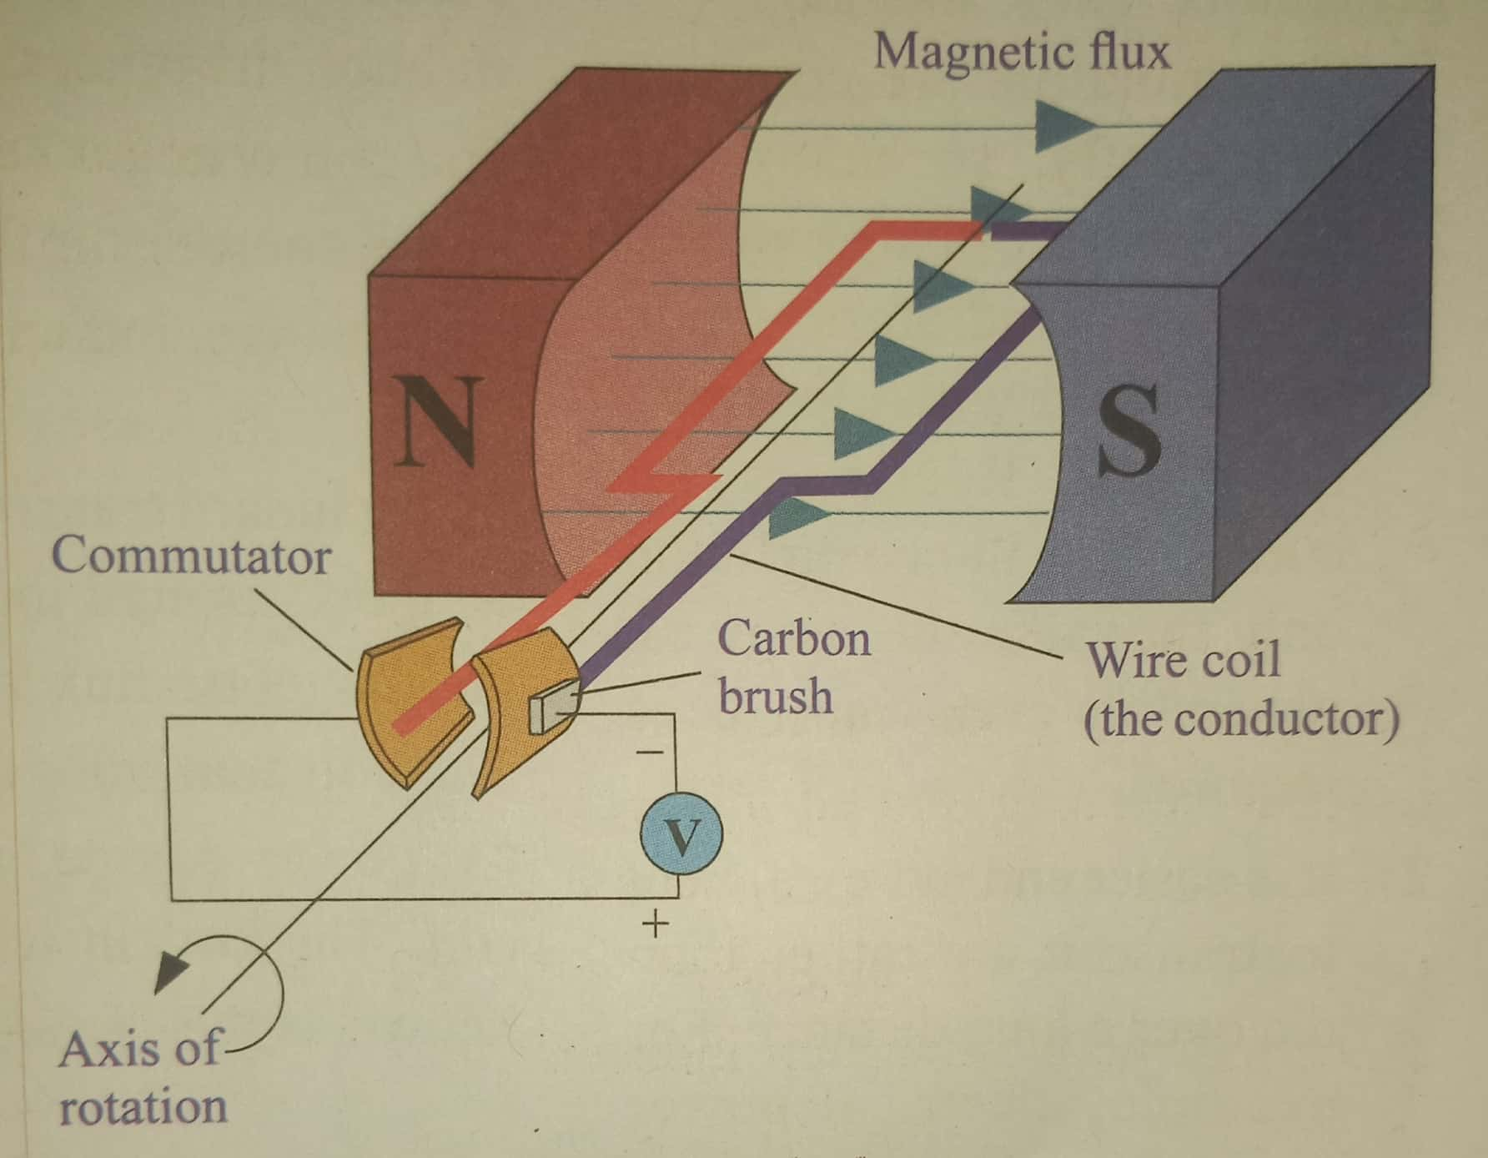

(b) A coil rotates because as the current flows through it, a magnetic field is developed around the coil. This magnetic field is always such that it opposes the existing magnetic field resulting into repulsion (Lenz’s law); therefore, a force is exerted on the coil since the coil is free to rotate then it does so;
The direction of rotation is perpendicular to the plane made by current and direction of the field. (Fleming’s left hand rule)……………………………..3 marks

(c) When the coil is perpendicular to the fields, it will not be able to rotate unless it is slightly pushed;…………………………….03 marks

